**SECTION 1 - BUSINESS IDEA**

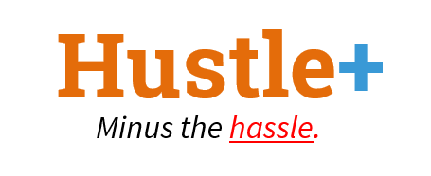

**Summary**

Hustle+ is an online marketplace for companies to offer tech projects to students with the relevant skills to complete them, using a commission-based business model.

**Brief Description**

Students in the tech industry today are not prepared enough to meet the requirements of employers. Current local education systems are strong in building students up with their theoretical knowledge, but students do not have enough opportunities to apply these theories onto real-world projects. On a peer-to-peer comparison basis, foreign tech talents are often more competitive and willing to work longer hours for a lower salary due to different social or cultural pressures.

Hustle+ provides a host of projects where students can apply their skills and develop real world experience. Companies registered with Hustle+ will be able to list their tech projects on the Hustle+ web application. Students who have created accounts on Hustle+ can look through these listed projects and sign up for the ones which they have interest in. On top of that, they are also able to source for potential project mates with complementing skills through the mobile app. Selected students of a particular project will go through the training provided by the company and work on the project for the specified period of time.

Through this platform, companies are able to identify their desired students to work on their projects and students will be able to gain exposure to the tech industry by working on real-world projects.

**SECTION 2 - BUSINESS MODEL**

**Value Proposition**

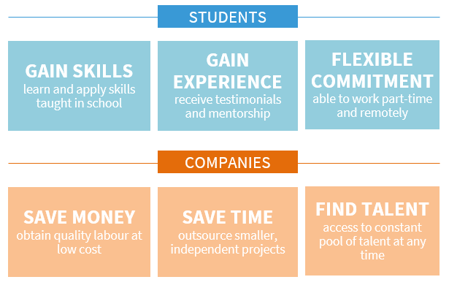

*Figure 1 Value Proposition of Hustle+*

Hustle+ provides a host of projects where they can apply their skills and develop real world experience. Through the projects and training provided, we aim to bring students to the next level of technical competency.

Start-ups and SMEs often are tight on money, and thus not able to hire professional developers or experienced but also expensive freelancers who have less flexibility in time than students. Hustle+ will be able to provide these companies access to a flexible pool of talent at any time. They can pick and choose the individuals that possess the right skill sets to suit their needs across different sectors within the tech industry.

Hustle+ will be the platform for companies to list projects to students who are screened and verified as having the right skills and competencies to complete the projects in a timely and professional manner.

**Revenue Model**

Hustle+’s main revenue stream will be its commissions from matching students to microprojects. Companies can register and list their fixed-price projects on the marketplace for free, but will have to pay a commission for every successful match based on the following structure:

* 10% of total job value on the first successfully match in the month
* 15% of total job value on every subsequent successful match within the same month

The percentage values are derived from the market rate of commissions for freelancing platforms like Fiverr or Upwork.

Payment will be made through a number of gateways such as Paypal, Stripe (for all credit card types) and possibly Cryptocurrency. We are also interested to offer payment options such as AXS payment, Local Bank Transfer, DBS Paylah!, NETS Pay, GrabPay.

**Target Group**

We are targeting local Singaporean start-ups and SMEs who lack the talent and bandwidth required to complete non-critical projects. As such, they can list projects for students to take up.

For the talents, we are targeting the large group of tertiary students in Singapore, who have the skillset and time to complete microprojects. In NUS School of Computing alone, there are already more than 2000 students[1], showing that this market is large enough to tap on.

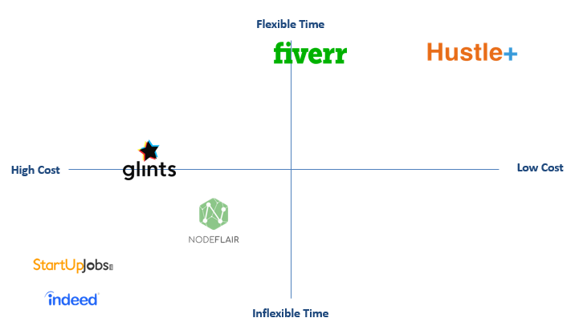

*Figure 2: Competitive Analysis*

**Competitive Environment**

Hustle+ will be competing against platforms such as Fiverr, Glints, NodeFlair, StartUpJobs and Indeed as shown in Figure 2. These companies offer a similar service which is to connect companies with people who are looking for opportunities to work on projects or roles.

**Competitive Advantage**

Hustle+ is advantageous for both our stakeholders: companies incur much lower costs compared to hiring interns or temporary staff. In fact, cost is determined by the companies themselves (a.k.a commissions given upon completion of the project). Especially for start-ups who lack money, this marketplace forms a bridge between companies sourcing for skilled manpower and students who can complete commissioned projects; on the other hand, students will be able to give their profiles a boost while working on a short-term project, which is important in Singapore’s competitive tech industry today.

**Website** *(For Companies & Admin Staff - to register projects and find students)*

|  |  |
| --- | --- |
| **Use Case** | **Use Case Description** |
| Login | Company representative logs into the Hustle+ system. |
| Logout | Company representative logs out of the Hustle+ system. |
| Register Company | Company representative registers an account on behalf of the company. |
| Delete Company | Company representative removes the company from the Hustle+ marketplace. |
| View Company Profile | Company representative views the selected company’s profile. |
| Update Company Profile | Company representative edits the details of the company’s profile. |
| List Project(s) | Company representative creates a new project to be listed on Hustle+. |
| Search for Students | Company representative uses the search function to look for students fit for their listed projects. |
| Email Student | Company representative sends an email to the desired student that they want to hire to do their project. |
| Review Student | Company representative reviews a student that has completed a project with them. |
| Create Milestones | Company representative creates a milestone for a project with a timeline and description. |
| Update Milestones | Company representative updates milestone details. |
| Delete Milestones | Company representative delete milestones on a project. |
| Release Payment | Company representative release payment to student when milestones are completed. |
| Verify Company | Admin staff verifies that the company is authentic. |
| Verify Student | Admin staff verifies that the student is skilled with a certain technology. |

**Mobile Application** *(For Students - to find teammates and projects)*

|  |  |
| --- | --- |
| **Use Case** | **Use Case Description** |
| Login | Student logs into the Hustle+ system. |
| Logout | Student logs out of the Hustle+ system. |
| Register Student User | Student registers an account. |
| Delete Student User | Student removes his/her account from the Hustle+ marketplace. |
| View Student Profile | Student views profile with details such as profile photo, resume, student reviews and essential information. |
| Update Student Profile | Student updates profile information. |
| View List of Projects | Student views a list of projects. |
| View Project Details | Student views specific project details. |
| Apply for Projects | Student submits an application for project opening. |
| Search for Projects | Student search by projects by Projects/Company/Teammates. |
| Email Company | Student can email company to seek clarification of details. |
| View Available Teammates | Student can view all students who are available as teammates on the marketplace. |
| Search for Teammates | Student can use the search function to find potential teammates. |
| Chat with Teammate | Student can message a particular teammate. |
| Add Teammate | Student can add another student as a teammate in his project team. |
| Remove Teammate | Student can remove another teammate from his project team. |
| Rate Teammate | Student rates another teammate that he has worked on a project with. |
| Rate Company | Student rates a company that he has completed a project with. |
| Review Teammate | Student reviews another teammate that he has worked on a project with. |
| Review Company | Student reviews a company that he completed a project for. |

1. Summary of Undergraduate Enrolment <http://www.nus.edu.sg/registrar/info/statistics/ug-enrol-20182019.pdf>